# Multi Node Cluster using GCP

Steps:

1. Create GCP account – free tier
2. Create VM instances
3. Create SSH public and Private keys to enable password less interaction between VM machines (Nodes)
4. Install AMBARI in one of the nodes
5. Provision the HDP services by using AMBARI

## Create GCP account – free tier

Refer attached document



## Create VM instances

Creating 5 instances:

Go to Console

Search 🡪 Compute Engine 🡪 VM instances 🡪 Create Instance

Create

Name of the Instance

Select Region, Zone

General Purpose Machine 🡪 Min 2core machine, 8GB RAM, 20GB storage

## Create SSH public and Private keys to enable password less interaction between VM machines (Nodes)

PuttyGen to create a key – SSH

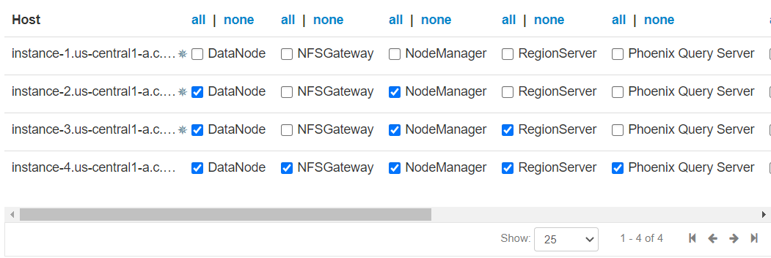

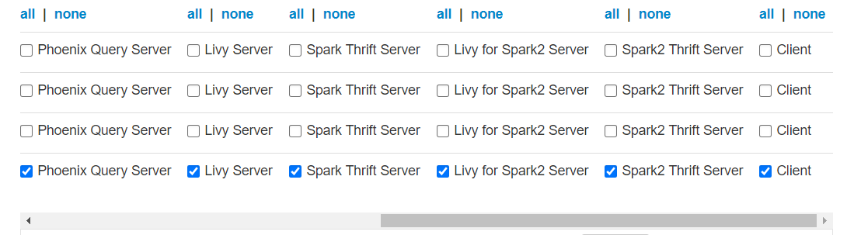

Go to errors:

Hive – create password

Oozie – select derby for database, create username and password

